Tennessee Communication Association

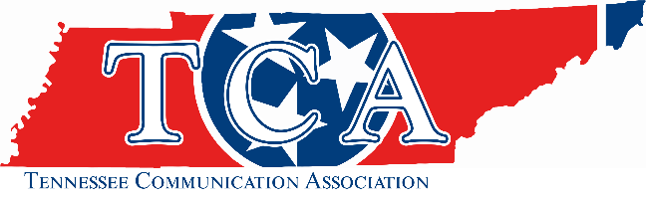

Kentucky Communication Association

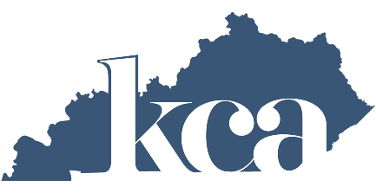

2023 Joint Conference
Friday, September 22 - Saturday, September 23, 2023
Tennessee Tech University
Cookeville, Tennessee
Theme: Looking Forward: Exploring the Future of Communication Education

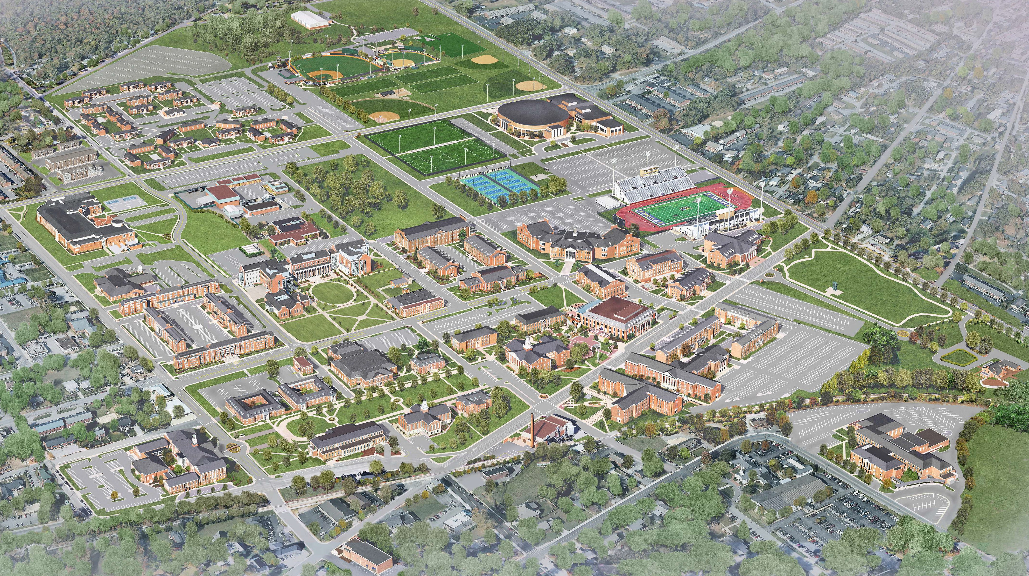

































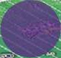
















Parking for Friday is in Yellow (upper Left area of the map). Bus will be available
Parking for Saturday is purple behind Bell Hall
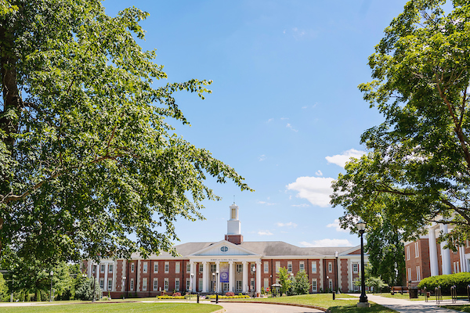
September 2023
Dear TCA Members and Guests,
Welcome to the 2023 TCA conference. Thank you for your attendance and participation.
We are excited to be on the campus of Tennessee Tech University in Cookeville, Tennessee. This 2023 conference would not be a success without you as presenters, attendees, and guests.

Thank you to the Kentucky Communication Association for this joint effort. The leadership teams for the Kentucky and Tennessee Communication Association should be commended for their work behind the scenes.

Our work is ongoing as we continue to represent our discipline at the state level and beyond. We are faced with legislation and changes that are impacting our scholarship and students.

The 2023 conference theme of Looking Forward: Exploring the Future of Communication Education provides us with a framework to how we can improve as scholars and teachers.

Thank you for allowing me to represent the TCA organization this past year.
I encourage you to meet some new colleagues and build relationships.
Please enjoy the conference. We are glad you are here.

Shaquille “Shaq” O’Neal Marsh, PhD.
2022-2023 TCA President


Conference Schedule Overview
Friday, September 22

11:00 a.m. – 6:00 p.m. – Registration: Robert & Gloria Bell Hall
12:15 p.m. – 12:40 p.m. – Welcome by TCA/KCA Presidents, Celebrations of Life & Lifetime Achievement
12:40 p.m. – 12:50 p.m. – Remarks from Tennessee Board of Regents
1:00 p.m. – 1:50 p.m. – Session 1: Bell Hall Rooms 260, 264 & 266
2:00 p.m. – 2:50 p.m. – Session 2: Bell Hall Rooms 260, 264, & 266
3:00 p.m. – 3:50 p.m. – Session 3: Bell Hall Rooms 260, 264, 266,&282
4:00 p.m. – 4:50 p.m. – Session 4: Bell Hall Rooms 260, 264, & 266
5:00 p.m. – 6:30 p.m. – Dinner: Bell Hall Room 260
6:30 p.m. – 8:30 p.m. – Student Film Showcase: Bell Hall 282
Saturday, September 23

8:00 a.m. – 10:00 a.m. – Registration: Robert & Gloria Bell Hall
8:00 a.m. – 8:50 a.m. – Session 5: Bell Hall Room 266
9:00 a.m. – 9:50 a.m. – Session 6: Bell Hall Rooms 260, 264, & 266
10:00 a.m. – 10:50 a.m. – Session 7: Bell Hall Rooms 260, 264, & 266
11:00 a.m. – 11:50 a.m. – Session 8: Bell Hall Rooms 264 & 266
12:15 p.m. – 1:30 p.m. – Luncheon & Award Presentations: Bell Hall

Welcome – 12:15 – 12:50 p.m. | Friday, September 22

12:15 – 12:20 Welcome from Presidents of TCA/KCA

12:20 – 12:30 Celebrations of Life - Kentucky

12:30 – 12:40 Lifetime Achievement – Tennessee

12:40 – 12:50 Remarks from Tennessee Board of Regents

Session 1 – 1:00 – 1:50 p.m. | Friday, September 22

Session 1A: Bell Hall 264

Panel Title: Handicrafts as Communication
Dr. Erin E. Gilles, University of Southern Indiana
Dr. Emily Hofelich, Eastern Kentucky University
Dr. Kathy Previs, Eastern Kentucky University

This panel will explore how crafters use small groups and social media to communicate about their projects, form communities, sell stitching-related tool and patterns, and celebrate their fandoms, histories, and identity through their work. This discussion will also explore broader social constructs by unpacking the meanings each of these handicraft forms has for crafters. Finally, we will discuss the methods by which communication researchers tell the stories of crafters, be it though film (documentaries) or though analyses of social media platforms.
Moderator: Dr. Erin E. Gilles-University of Southern Indiana
Session 1B: Bell Hall 260

Panel Title: RSI and the Communication Classroom: Enhancing Communication in an Online World.
Dr. Jessica Morris, Austin Peay State University
Dr. Tracy Giovanetti, University of Memphis Lambuth
Dr. Pam Gray, Austin Peay State University
Dr. Tracy Nichols, Austin Peay State University

Online learning is continuously changing. Classroom management and instructor/student interaction has become more platform based and may be less engagement focused. In 2020, the U.S. Department of Education set forth a mandate requiring “regular and substantive interaction” (RSI) between students and instructors in online classrooms a requirement for education supplemented by federal financial aid. As universities and community colleges work toward meeting this goal for all distance learning courses, many are left with questions about meeting the requirements while maintaining stability of the course and manageable time constraints for the faculty and distance education students. Considering the conference theme of looking forward to explore the future of communication education, this panel will consider student and faculty perspectives. The panel will discuss ideas for substantive engagement, best practices, tools for change, and methods for interaction that allow the freedom and flexibility distance education students seek, while also advancing the communication classroom and preparing communication students for current and future online professional interaction and careers
Moderator: Dr. Erin E. Gilles-University of Southern Indiana
Session 1C: Bell Hall 266

Panel Title: AI for Forensics: Research or Not
Rob Pratt- Walters State Community College
Belle Elliott- Walters State Community College
Jacob Metz- Tennessee Tech University
Dr. Kurtis Miller- Tusculum College
Dr. Patrick Richey- Middle Tennessee State University
Dr. Shaquille Marsh- Pellissippi State Community College

Since the theme of the 2023 TCA Conference is Looking Forward: Exploring the Future of Communication Education, what role will artificial intelligence (AI) play in the arena of forensics? Is it ok for competitors to use AI to develop their arguments? Is it ok for AI to write their speeches? What standards should we hold to help students develop their own thoughts? The present and future forensics competitions must address these questions and more as we look to help our students become effective communication professionals. This roundtable discussion will feature forensics coaches from an array of backgrounds and provide their positions on AI and Forensics.
Moderator: Rob Pratt- Walters State Community College
Session 2 – 2:00 – 2:50 p.m. | Friday, September 22

Session 2A: Bell Hall 264

Panel Title: Activism and the Media Lens
“But if Not”: Martin Luther King’s Sacred Narrative Trajectory Looks Forward to Street Level Activism
Rusty Woods, University of Memphis
In November of 1967 Martin Luther King, Jr. delivered a sermon titled “But if Not” which rhetorically offers a clever prophetic movement that, when set against the backdrop of King’s historical situation, displays intentional storytelling designed to propel the “people of the Book” backward into the story and then forward into the street.
Tyre Nichols and Terministic Screens
Rusty Woods, University of Memphis
Looking back at news media frames can help scholars look forward to incoming news as well as help students do so with a better-trained eye. The attack and subsequent death of Tyre Nichols garnered local and national media attention, and so did the release of local reaction to the videos. How do mediated headlines reflect, select, and deflect how potential protestors could be perceived by viewers for the purpose of reframing frame words in a more helpful and considerate manner open to the positive purposes and function of protestors?
Session 2B: Bell Hall 266

Panel Title: Rhetoric and Public Address
Symbolic Convergence Theory and Escapism: An Analysis on Animated Portrayals of Family Dynamics
Rebekah Witemeyer- Middle Tennessee State University
For nearly 100 years, Walt Disney Animation Studios has been creating unique, family-friendly films that have inspired generations. In many situations, this can be encouraging for young children who see aspects of their own life in the lives of their favorite Disney characters. However, this is not always the case, as issues can arise for children relating to situations outside of the stereotypically brave, kind, and lighthearted films that one would expect from Disney.
Additionally, there is a noticeable difference between the problem-solving methods of classic Disney characters portrayed in films such as Cinderella (1950) compared to newer 21st century Disney characters in films like Encanto (2021). While these films are mainly fictitious, the impact that lifelike portrayals of everyday issues can have on children is larger than most adults may realize. In the mind of a child, they are seeing representations of their own lives on a vivid screen, and it can affect not only their views, but their actions towards their family as well.
When themes like divorce, sibling rivalry, or adoption are negatively communicated in films, children who have their own experiences with these are likely to compare these portrayals with their own life. This analysis uses a lens of symbolic convergence theory to begin a discussion on how animated media is affecting children’s perception of common family dynamics, and what action may be needed to prevent any negative effects that may result.
Mute Purpose of the Advanced Placement Program and the Effect it has on Secondary Education Students
Jessica Rogers- Middle Tennessee State University
Evaluating the relevance to secondary education students and the purposes behind the Advanced Placement Program through the analysis of the College Board’s communicated intentions and behavior. Utilizing the ideology criticism method, through the evaluation of the 2020 AP Exam, the investigation revealed that the primary purpose of the AP Exams stated by the College Board company did not match their nonverbal communication exemplified by their reaction to the Covid-19 virus and other actions that effected students ability to gain Advanced Placement credit through direct correlation revealing secondary motives that overpower the public explanations behind the exam. The AP program, designed by the college board, is a course designed to prepare students for post-secondary education or college while remaining in secondary education or high school.
However, the actions of the College Board Organization in response to the 2020 pandemic reveal a mute purpose that contradicts the primary purpose as they altered the credit awarding exam not to test the students properly but to prevent a mass refund of the program fee. The rhetorical analysis, utilizing the ideology criticism theory, reveals how the main focus of the AP Exam is to earn money over the advancement of secondary education students negating the benefits promised by the College Board organization.
Moderator: Dr. Erin E. Gilles-University of Southern Indiana
Session 2C: Bell Hall 260
Panel Title: Communicating Themes in the College of Liberal Arts Moderator: Dr. Janet McCormick,

Dr. Amy Sayward, Middle Tennessee State University
Dr. Jim Chaney, Middle Tennessee State University
Valeri Buck, MTSU, Middle Tennessee State University Master of Arts in Liberal Arts Student
Jason Lukawitz, Middle Tennessee State University Master of Arts in Liberal Arts Alum
The purpose of this panel is to share with TCA members how faculty involved in the Master of Arts in Liberal Arts program at MTSU “teach to a theme” in the two required Foundations courses (MALA 6000/6010 Foundations of Liberal Arts I and II). Specifically, a theme is chosen each academic year (exs. experience, communication, knowledge). For each course, 6 professors teach 2 class periods in a row on the common theme from their perspective within the 12 departments of the Liberal Arts. At the end of the semester, the students write a reflection paper on the theme as communicated by the various professors.

Moderator: Dr. Janet McCormick- Middle Tennessee State University
Session 3 – 3:00 – 3:50 p.m. | Friday, September 22

Session 3A: Bell Hall 264

Panel Title: The Effects of Interpersonal Familiarity on Trust, Motivation, and Likelihood to Use Alternative Uncertainty Reduction Strategies to Detect Deception

Dr. David Randall Brandt, Northern Kentucky University
Dr. Whittney H. Darnell, Northern Kentucky University
Lydia T. Ostertag, Northern Kentucky University
This study explores how interpersonal familiarity is linked to trust, motivation, and likelihood to use alternative uncertainty reduction strategies to determine if a person is lying or telling the truth. Five hypotheses were developed and tested via an experiment involving a situation where a (potential) deceiver did something unexpected and explained his/her behavior that may or may not have been truthful: This person was a close friend in one experimental condition (high familiarity), and a new acquaintance in the other (low familiarity).
Session 3B: Bell Hall 266

Panel Title: Being a Black Man in the Academy: Realities of Working at a PWI
Dr. Shaquille Marsh- Pellissippi State Community College
In this presentation, I will discuss the book chapter I wrote called Classroom Dynamics: Hidden Truths while Black for the book We’re Not OK: Black Faculty Experiences and Higher Education Strategies published by Cambridge University Press. I will discuss the realities of being a Black man in the academy at Predominately White Institutions (PWIs). There will be a question-and-answer session for participants.
Moderator: Natonya Listach- Middle Tennessee State University

Session 3C: Bell Hall 260

Panel Title: The Rise of the Machines: Engaging with AI and Machine Learning in the Communication Classroom.
Dr. Rob Baron- Austin Peay State University
Sheri Waltz- Volunteer State Community College
Mike Dunn- Austin Peay State University
Bambi Pelham- Walters State Community College

The explosive growth of ChatGPT, Google Bard, and other AI tools are drastically reshaping the creative and professional world. As we prepare students to enter these worlds, we must consider the consequences of these new technologies. This round table discussion will explore how we, as communication scholars, instructors, and professionals engage with, use, and teach about these new tools. Participants will bring their own experiences in teaching with, and around, AI as well as their efforts to establish departmental and institutional policies regarding AI in the classroom.

Moderator: Dr. Rob Baron- Austin Peay State University

Session 3D: Bell Hall 282
Title: Storytelling Workshop
Brandon Bragg- Northeast State Community College
Stories have shaped people and philosophies for many years, and storytelling has been a means of preserving and perpetuating cultures, beliefs, and traditions from man’s humble beginnings. In a short workshop we will look at why stories and storytelling are engrained in civilization. We will examine why it remains an important part of all walks of life. We will also explore the elements of shaping and delivering an appealing and influential narrative. I hope you can join in this enlightening and entertaining workshop.
Session 4 – 4:00 – 4:50 p.m. | Friday, September 22
Session 4A: Bell Hall 264

Panel: Developing Basic Course Faculty: A Three-Tiered Approach

International Pedagogy: Higher Education in a Globalized World

Dr. Jennifer Fairchild, Eastern Kentucky University
Prof. Krista Kimmel, Eastern Kentucky University
Prof. John Strada, Eastern Kentucky University
In general education classes, engaged faculty are of the utmost importance, given that students are often resistant to taking these courses for several reasons. Thus, we propose a three-tiered system to engage faculty teaching general education courses. This three-tiered approach focuses on not only the development of faculty as teachers but also supports their growth as professionals and leaders. This approach includes strategies for training, mentoring, and sponsoring basic course faculty in their professional development and engagement. As this session is a roundtable, audience participation is encouraged.
Moderator: Michael G. Strawser- Bellarmine University

Session 4B: Bell Hall 266

Panel Title: Curriculum & Instruction
Use of Open Educational Resources (OER) Basic Public Speaking Course
Katie Gruber- Middle Tennessee State University
As an instructor of the basic public speaking course for the past 15 years, I understand the importance of students gaining access to course materials from day one. Our time is limited, as much of the class is spent delivering speeches. I also know the additional cost of a textbook can create further stress and delays in learning. The basic public speaking course is not only the “front porch” of the discipline but also a predictive course for future student success.
As such, it is imperative to adapt to the ever-evolving needs of students and reduce barriers to their success. One way to adapt to their needs is by using open educational resources (OER). After successfully piloting use of OER in the basic public speaking course in Fall 2021, I completed a Pressbook in June 2022 for use in Fall ’22 and Spring ’23 semesters. End-of-course papers from both semesters asked students about their attitudes towards and reading of the Pressbook. Students showed favorable attitudes towards OER, with a great majority praising my efforts to use OER instead of a traditional textbook and reflecting that they read as much or more of our text than they would have if we had used a traditional text.
Finally, I incorporated open educational practices (OEP) by adding exemplary student work to our textbook. This creates a connection with students and allows them to share their stories with others and allows future students to see real student work.
In this panel, I will share students’ final reflections about using OER and OEP in the basic public speaking course. This presents an exciting opportunity for other Communication faculty to begin using OER and OEP.

Creating Competency Based Education Fundamentals of Communication Course
Dr. Ruth Livingston- Northeast State Community College
In April 2023, I was hired by the Tennessee Board of Regents to create a Competency Based Education Fundamentals of Communication course. This work was completed in June 2023. In this presentation, I will explain what CBE courses are and the TBR initiative to create CBE courses for 40 General Education Courses. Participants will be given an overview of the Online version of the CBE Fundamental Course.

Tennessee Community Colleges: Debunking Myths, Misconceptions, and Misinformation
Stephanie Tanksley- Austin Peay State University
Tennessee community colleges have long been stereotyped as “less than” in comparison to four-year institutions because of the misconceptions, misinformation, and myths surrounding community colleges in the state. However, community colleges offer students exploration of educational opportunities they never considered before since higher education and communication has shifted since coming out of the Covid-19 pandemic. Through the lens of an incoming freshmen studying Communication Education, this paper explores ways a community college proves its worth and value as a higher education institution by including what it means to have open enrollment, understanding the misperception of lower quality of education, and if the weight of degrees is less valuable than that of a four-year institution. Additionally, this paper uses the mass communication inoculation theory to shield from or “build immunity” from fallacies if one is faced with incorrect information.

The Digital Shift in Communications Education: Scantrons to E-Tests
Brian Hamilton- Walters State Community College
One of the first concepts that we introduce to students in a basic communication course is the transactional model of communication. If all an instructor does is to present the model, explain its parts, and move on to the next topic, students often gain an academic understanding of the concept, but are left without the ability to practically apply the model to communication events that occur within their life. This leaves students unable to improve their “real-life” communication skills. This exercise is designed to give students a practical understanding of the transactional model of communication in addition to improving student’s academic understanding of the model. This exercise allows students the opportunity to see different areas in the model where communication can break down and then gives students the tools to help prevent those communication problems outside of class.

Moderator: Dr. Scott Christen- Tennessee Tech University

Session 4C: Bell Hall 282

Presentation/Performance Title: Great Ideas for Teaching Students (G.I.F.T.S)

Introduction and Conclusion Speed Exchange
Dr. Stephanie Montgomery- University of North Alabama
Podiums, Pedestals, Platforms, and Pulpits
Brandon Bragg- Northeast State Community College
Don’t Communicate: A Game to Understand the Impossibility of Avoiding Nonverbal Communication
Jacob Metz- Tennessee Tech University
Revisioning Maslow
Rebecca Richey- Middle Tennessee State University
Moderator: Brandon Bragg, Northeast State Community College
Special Events

Dinner – 5:00 – 6:30 p.m.: Bell 260

Student Film Showcase – 6:30 – 8:30 p.m.: Bell Hall 282 Auditorium

Session 5 – 8:00 – 8:50 a.m. | Saturday, September 23

Session 5A: Bell Hall 266
Roundtable Discussion: General Education 3.0 The Future of General Education in Higher Education
Malcolm McAvoy- Walters State Community College
Marci Nimick- Walters State Community College
Len Assante- Volunteer State Community College
Dr. Erin E. Gilles - University of Southern Indiana
Connie Hudspeth- Seminole State College
Jeffrey Fox- Northern Kentucky University
The panel will review the current state of General Education and examine future trends with special emphasis on the Communication Fundamentals Course.
Moderator: Malcolm McAvoy- Walters State Community College (Retired)
Session 6 – 9:00 – 9:50 a.m. | Saturday, September 12

Session 6A: Bell Hall 264
Scholarly Paper: A Toolbox for the Future of Communication Education Scholars: How Have We Helped and Hurt Ourselves?
Dr. Mary Ashlock, University of Louisville
Julie Keehn, University of Louisville
Is face- to-face communication still relevant in our virtual world? Perspectives and insights from a Baby Boomer Generation communication faculty member and Gen Z graduate student present meaningful ways in which to use different communication channels. Key points emphasize the need to expand cross-disciplinary collaboration through educators with expertise in communication. Insights and ideas that communication experts can employ to demonstrate their added value as professors, consultants, and facilitators.
Session 6B: Bell Hall 260
Roundtable Discussion: Using our Undergraduate and Graduate Communication Courses to Build Strong Community Partnerships
Dr. Janet McCormick- Middle Tennessee State University
Carol Swayze- Middle Tennessee State University
Dr. Tracy Nichols- Austin Peay State University
The purpose of this panel is to share with TCA members examples of Experiential Learning (EXL) assignments and opportunities incorporated into Communication courses at the undergraduate and graduate levels to create and maintain strong community connections.
Moderator: Jacob Metz- Tennessee Tech University
Session 6C: Bell Hall 266

Panel Title: Abraham Lincoln’s Inaugural Addresses as Crisis Communication?
Dr. Abram Book, Southeast Missouri State University
Abraham Lincoln is America’s most beloved president and an oratorical giant. This paper takes a fresh look at his two inaugural addresses, with the goal of understanding how Lincoln used what we now know as crisis framing in his first inaugural and crisis response strategies in his second in an attempt to mollify the secession crisis, help the country cope emotionally with the aftermath of the war, and set the stage for reconstruction.

Session 7 – 10:00 – 10:50 a.m. | Saturday, September 23

Session 7A: Bell Hall 264

Scholarly Papers: Health Communication for the Future
When Health Messages Go Wrong: Looking to the Future of Patient Portal Technologies
Dr. Crystal Daugherty, Western Kentucky University
There are major implications when considering the future of health communication and the various technologies that are employed by both patients and providers. First, as researchers and scholars we are tasked with better understanding the use of technologies to deliver messages to patients.
Factors Associated with Food Pantry Use on Campus & Outgoing Communication Recommendations for Increasing Awareness Among Students
Dr. Lindsay J. Della, University of Louisville
Bunny Hayes, University of Louisville
Dr. Kristi M. King, University of Louisville
Dr. Siobhan E. Smith-Jones, University of Louisville
As an urban campus with a diverse student body and large contingent of first-generation college students, the University of Louisville’s student composition differs from other traditional undergraduate campuses. We explore factors associated with use of the Cardinal Cupboard, a food pantry for students at the University of Louisville and explore its promotional activities.
Session 7B: Bell Hall 266

Roundtable Discussion Small Group Communication

Dr. Colleen Mestayer- Tennessee Tech University
Amy Hill- Tennessee Tech University
Jacob Metz- Tennessee Tech University
Megan Tillis- Tennessee Tech University
This panel discussion will focus on how to gain the various benefits of using group work in the classroom by avoiding the pitfalls that often plague instructors. The benefits of group work have been well documented. For instance, research reveals greater student motivation and creativity (Rezaei, 2020), and higher levels of academic performance, increased social skills, and greater satisfaction with the experience (Badache, 2011; Hammar-Chiriac 2014; Šerić & Garbin, 2018); however, group work can be cumbersome and daunting to instructors, and is often not incorporated into the classroom as often as it could be.
You will learn why classroom groups work, how to get the most out of your classroom group work, how to avoid common pitfalls, and some tips and activities to enhance the group experience in your classroom.
Session 7C: Bell Hall 260
Roundtable Discussion: "Mind the Gap": Mitigating Ableism in Communication Education
Rebecca Richey- Middle Tennessee State University
Natonya Listach- Middle Tennessee State University
Dr. Patrick Richey- Middle Tennessee State University
One of the challenges of gen ed classes is that a wide variety of student abilities and disabilities will be present among our students. The disability services at many of our campuses does an admirable job of helping create and facilitate accommodations to make sure every student has equitable access to classroom success.
However, there are some areas where we as the instructors can help create better classroom policies, grading rubrics, and general understanding to bridge the gaps between what disability services provides and what the students need. This panel seeks to identify some of those gaps and offer ethical, practical solutions that will meet the needs of the students while maintaining the integrity of the classroom goals.
Moderator: Dr. Shaquille Marsh- Pellissippi State Community College
Session 8 – 11:00 – 11:50 a.m. | Saturday, September 12

Session 8A: Bell Hall 264
Scholarly Papers: Communication in Current Media
Exploring Black Feminism and Emotional Intelligence Leadership in Black Panther: Wakanda Forever
Carlos Matthews, Northern Kentucky University
This session will explore Black feminism and emotional intelligence leadership in the movie Black Panther: Wakanda Forever. Qualitative content analysis will be used to learn how Black women (Shuri, Ramonda, and Okoye) use emotional intelligence leadership to lead the nation of Wakanda.
Viewer Engagement via Dual-Screening & Netflix’s Monster: The Jeffrey Dahmer Story
Dr. Erin E. Gilles, University of Southern Indiana
This limited series covered the life and crimes of one of America’s most notorious serial killers. Known as the “Milwaukee Cannibal,” Dahmer killed and dismembered 17 men and boys between 1978 and his arrest in 1991. This session will explore themes found in online discussions of the series and examine fan reactions and the “dual screening” that occurs when fans watch and discuss programs on social media.
Session 8B: Bell Hall 266

TCA competitive student paper submissions for Fall 2023

Paper Title: Greenwashing from a Marxist Perspective
Haley Jones- Middle Tennessee State University
Faculty Mentor- Dr. Patrick Richey
Paper Title: Blood, Toil, Tears, and Sweat
Charles Wilhite- Pellissippi State Community College
Faculty Mentor: Dr. Shaquille Marsh
Paper Title: Exploring Communication Competence and Psychological Health: A Study of Cross-cultural Adaptation among Young Japanese Immigrants in the U.S.
Erika Higashide- Middle Tennessee State University
Faculty Mentor- Dr. Yang Soo Kim

Paper Title: Social Media Mourning and the use of COVID-19 Grief Memes: A Look at Yellow Hearts
L’Oreal Stephens- University of Memphis
Faculty Mentor- Dr. Amanda Young
Paper Title: Experience
Valeri Buck- Middle Tennessee State University
Faculty Mentor- Dr. Janet McCormick
Moderator: Dr. Shaquille Marsh-Pellissippi State Community College

End of Sessions | Saturday, September 12

Luncheon and Award Presentations – 12:00 – 1:00 p.m., Bell Hall 260

Saturday, September 12

Business Meetings – 1:00 – 2:00 p.m.

- KCA Business Meeting: Bell Hall 264

- TCA Business Meeting: Bell Hall 266

Kentucky Communication Association
2022-2023 Executive Council
Immediate Past President: Jeffrey Fox, Northern Kentucky University
President: Mary Ashlock, University of Louisville
First Vice-President: Abra Endsley, Eastern Kentucky University
Second Vice-President: Krista Kimmel, Eastern Kentucky University
Member at Large 1: Andrew Bolin, Kentucky Wesleyan University
Member at Large 2: Audrey Deterding, Lindsey Wilson College
Treasurer: Gary Hughes, Western Kentucky University
Secretary: Dana Seay, University of Louisville
Executive Director: Randall Brandt, Northern Kentucky University
Journal Editor: Erin Gilles, University of Southern Indiana

Tennessee Communication Association

2022 – 2023 TCA Officers

President: Dr. Shaquille Marsh, Pellissippi State Community College
President-Elect: Dr. Scott Christen, Tennessee Tech University
Executive Director: Dr. Ruth Livingston, Northeast State Community College
Past President: Dr. Patrick Richey, Middle Tennessee State University
Webmaster: Dr. Scott Christen, Tennessee Tech University
Student Film Festival: James Livingston, East Tennessee State University
2022 – 2023 TCA Interest Chairs
Argumentation/Forensics: Dr. Karen Johnson- Volunteer State Community College
Corporate/Organizational: Mary White-Chattanooga State Community College
Curriculum/Instruction: Jacob Metz-Tennessee Tech University
Great Ideas for Teaching Students (GIFTS): Brandon Bragg-Northeast State Community College
Interpersonal/Small Group: Teresa Collard, University of Tennessee-Martin
Mass Communication: Michelle McGuffin- Pellissippi State Community College
Rhetoric/Public Address: Natonya Listach- Middle Tennessee State University
Race and Gender: Natonya Listach- Middle Tennessee State University

Tennessee Communication Association
2024 Conference

Austin Peay University
Clarksville, TN
September 20 – 21, 2024
https://tennesseecommunicationassociation.org/

